Project: Hospital Assistant Chatbot using Rasa
Introduction
What is a Chatbot?
A chatbot is an AI program that can simulate human conversation.
Chatbots help users by:
- Answering questions
- Providing information
- Automating services
Hospital chatbots help patients quickly access healthcare information.

Problem Statement
Hospitals receive many repetitive queries such as:
- Doctor availability
- Appointment booking
- Hospital timings
- Emergency information
Handling these manually takes time.
Solution:
A chatbot that automatically responds to patient queries.

Objective of the Project ?(Milestone 3)
The objective of this project is to develop a hospital assistant chatbot that can:
- Answer common patient queries
- Provide doctor availability
- Provide hospital timings
- Assist with appointment booking
- Handle emergency information
Technologies Used
- Rasa
- Python
- YAML

Rasa Architecture
Rasa has two main components:

1️. NLU (Natural Language Understanding)
Understands user intent.
Example:
User: I want to book appointment
Intent: book_appointment

2️. Core
Manages conversation flow and responses.
Project Structure(Until Now)
Project folder structure:
RasaProject
│
├── actions
├── data
│ ├── nlu.yml
│ ├── stories.yml
│ └── rules.yml
├── domain.yml
├── config.yml
└── models

Intents Used
The chatbot understands these intents:
- greet
- goodbye
- book_appointment
- check_doctor
- hospital_timings
- emergency
- bot_challenge

Sample Conversation
Example interaction:
User: hi
Bot: Hello! Welcome to our hospital.

User: appointment please
Bot: Sure! You can book an appointment between 9 AM and 5 PM.

User: doctor availability
Bot: The doctor is available today from 10 AM to 4 PM.

Bot Features
The chatbot can:
- greet users
- answer hospital queries
- provide doctor availability
- give hospital timings
- assist with appointment booking
- handle emergency situations

Output

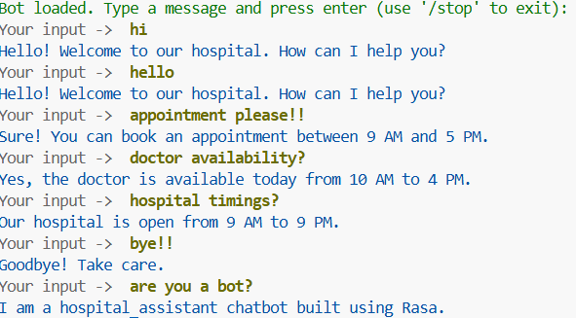

Future Enhancements (Milestone-4)
Future improvements include:
- database integration
- storing patient appointments
- collecting patient details
- connecting chatbot to website
- real-time doctor schedule

Conclusion
The Hospital Assistant Chatbot successfully demonstrates:
- Natural language understanding
- Automated patient assistance
- Efficient handling of hospital queries
This chatbot can help reduce workload on hospital staff.

